OED7208S 2相数字驱动器
OED7208S 2 Phase Digital Stepper Motor Driver
概述 Descriptions
OED7208S是精控电机新推出的数字式步进电机驱动器，采用最新32位DSP数字处理技术，驱动器控制算法采用先进的变电流技术和先进的变频技术，驱动器发热小，电机振动小，运行平稳。用户可以设置200~51200内的任意细分以及额定电流内的任意电流值，能够满足大多数场合的应用需要。由于采用内置微细分技术，即使在低细分的条件下，也能够达到高细分的效果，低中高速运行都很平稳，噪音超小。驱动器内部集成了参数上电自动整定功能，能够针对不同电机自动生成最优运行参数，最大限度发挥电机的性能.主要用于86mm 电机。
OED7208S is a new digital stepper motor driver by OEONGMOTOR. It adopts the latest 32-bit DSP digital processing technology. The drive control algorithm adopts advanced variable current technology and advanced frequency conversion technology. The driver has small heating, small motor vibration and stable operation. Users can set any subdivision within 200 ~ 51200 and any current value in the rated current to meet the application needs in most occasions. Thanks to the built-in micro-subdivision technology, the subdivision effect can be achieved even under the condition of low subdivision. The operation is smooth and the noise is ultra-small under low, medium and high speed. The driver integrates the parameter auto-adjust function, which can automatically generate optimal operating parameters for different motors to maximize the performance of the motor.

特点Features
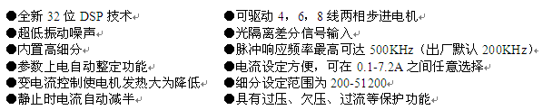
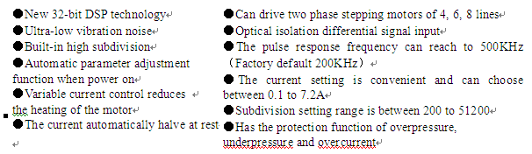
特点这个图片的有WORD 版本的。 请和我要一下。

应用Application
适合各种中小型自动化设备和仪器，例如：雕刻机、打标机、切割机、激光照排、绘图仪、数控机床、自动装配设备等。在用户期望小噪声、高速度的设备中应用效果特佳。

Suitable for all kinds of small and medium sized automation equipment and instruments, such as: engraving machine, marking machine, cutting machine, laser lighting, plotter, cnc machine, automatic assembly equipment, etc. It use very well in the equipment that user expects small noise, and high peed

电气指标和工作环境 Electrical, mechanical and environmental indicators
说明 | OED7208S
说明 | 最小值 | 典型值 | 最大值 | 单位
输出电流 | 0.1 | - | 7.2 | A
输入电源电压 | 24 | 48 | 75 | VDC
控制信号输入电流 | 6 | 10 | 16 | mA
控制信号接口电平 | 4.5 | 5 | 28 | Vdc
输入信号最小脉冲宽度 | 1.5 | - | - | us
步进脉冲频率 | 0 | - | 200 | KHz
绝缘电阻 | 100 |  |  | MΩ

使用环境及参数
冷却方式 |  | 自然冷却或强制风冷
使用环境 | 场合 | 不能放在其它发热的设备旁，要避免粉尘、油雾、腐蚀性气体，湿度太大及强振动场所，禁止有可燃气体和导电灰尘；
使用环境 | 温度 | -5℃ ～ +50℃
使用环境 | 湿度 | 40 ～ 90%RH
使用环境 | 振动 | 5.9m/s2MAX
保存温度 |  | -20℃～80℃
使用海拔 |  | 1000米以下
重量 |  | 约 280 克

Electrical indicators
Instruction | OED7208S
Instruction | Minimum | Typical | Maximum | Unit
The output current | 0.1 | - | 7.2 | A
Input voltage | 24 | 48 | 75 | VDC
Control signal input current | 6 | 10 | 16 | mA
Control signal interface level | 4.5 | 5 | 28 | Vdc
Input signal minimum pulse width | 1.5 | - | - | us
Stepper pulse frequency | 0 | - | 200 | KHz
Insulation resistance | 100 |  |  | MΩ

Using environment and parameters
Cooling method |  | Natural cooling or forced air cooling
Using environment | occasion | Can not be placed next to other heating equipment, should avoid dust, oil mist, corrosive gas, too big humidity and strong vibration place, prohibit to have combustible gas and conductive dust
Using environment | temperature | -5℃ ～ +50℃
Using environment | humidity | 40 ～ 90%RH
Using environment | vibration | 5.9m/s2MAX
Storage temperature |  | -20℃～80℃
Using altitude |  | Below 1000 metres
Weight |  | About 280 g

3、安装尺寸installation dimension
118
112
34
112
22.5
4.5
4-Ф3.5
75.5
25.3
47.8
Drawing 1 Installation dimension diagram (Unit:mm)

